Design Pattern

🧩 What is a Design Pattern?
# Source: AI Source: Provided by: [Data Path: Persons Table -> ID Column: 1, Name_En Column: Motasem Essam] -> From: [ChatGPT] on [1/23/2026]
A Design Pattern is a reusable solution to a common problem in software design.
It’s not actual code, but a template or idea you can apply in different situations.
👉 Design Pattern = Best practice for solving a repeated design problem

🔑 Simple Definition
# Source: AI Source: Provided by: [Data Path: Persons Table -> ID Column: 1, Name_En Column: Motasem Essam] -> From: [ChatGPT] on [1/23/2026]
A design pattern is a proven way to structure code to solve a specific problem efficiently.

🎯 Why Design Patterns Matter
# Source: AI Source: Provided by: [Data Path: Persons Table -> ID Column: 1, Name_En Column: Motasem Essam] -> From: [ChatGPT] on [1/23/2026]
- Avoid reinventing solutions
- Improve code quality and structure
- Make code easier to understand
- Provide a common language between developers
- Help build scalable and maintainable systems

🧱 Example Problem (Without Pattern)
# Source: AI Source: Provided by: [Data Path: Persons Table -> ID Column: 1, Name_En Column: Motasem Essam] -> From: [ChatGPT] on [1/23/2026]
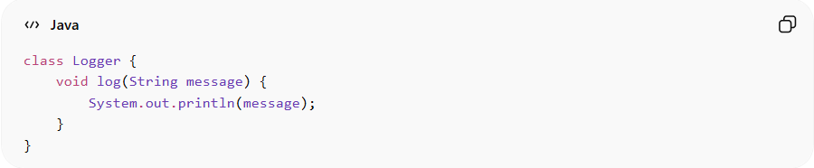
class Logger {
void log(String message) {
System.out.println(message);
}
}
👉 If multiple parts of the system create Logger objects → waste of resources

✅ Solution Using Design Pattern (Singleton)
# Source: AI Source: Provided by: [Data Path: Persons Table -> ID Column: 1, Name_En Column: Motasem Essam] -> From: [ChatGPT] on [1/23/2026]
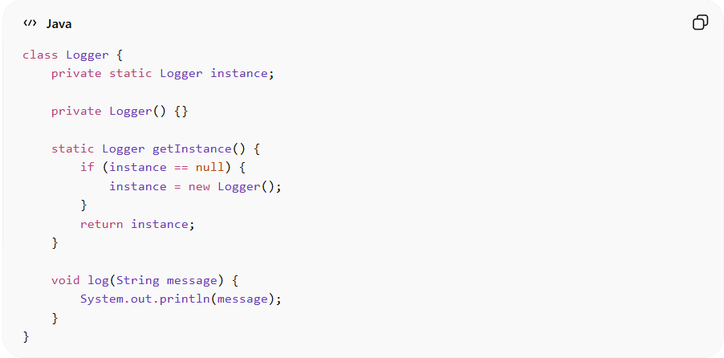
class Logger {
private static Logger instance;

private Logger() {}

static Logger getInstance() {
if (instance == null) {
instance = new Logger();
}
return instance;
}

void log(String message) {
System.out.println(message);
}
}
👉 Now:
- Only one instance exists
- Shared across the application

🧭 Types of Design Patterns
# Source: AI Source: Provided by: [Data Path: Persons Table -> ID Column: 1, Name_En Column: Motasem Essam] -> From: [ChatGPT] on [1/23/2026]
- 🏗️ Creational patterns → focus on how objects are created
- 🧱 Structural patterns → focus on how objects are connected
- 🔄 Behavioral patterns → focus on how objects communicate

1️⃣ Creational Patterns
# Source: AI Source: Provided by: [Data Path: Persons Table -> ID Column: 1, Name_En Column: Motasem Essam] -> From: [ChatGPT] on [1/23/2026]
👉 Deal with object creation
- Singleton
- Factory
- Builder

2️⃣ Structural Patterns
# Source: AI Source: Provided by: [Data Path: Persons Table -> ID Column: 1, Name_En Column: Motasem Essam] -> From: [ChatGPT] on [1/23/2026]
👉 Deal with object relationships
- Adapter
- Decorator
- Facade

3️⃣ Behavioral Patterns
# Source: AI Source: Provided by: [Data Path: Persons Table -> ID Column: 1, Name_En Column: Motasem Essam] -> From: [ChatGPT] on [1/23/2026]
👉 Deal with communication between objects
- Observer
- Strategy
- Command

💡 Key Idea
# Source: AI Source: Provided by: [Data Path: Persons Table -> ID Column: 1, Name_En Column: Motasem Essam] -> From: [ChatGPT] on [1/23/2026]
Design patterns are guidelines, not rules.
Use them when they simplify your design, not to make code more complex.

🚫 Common Mistakes
# Source: AI Source: Provided by: [Data Path: Persons Table -> ID Column: 1, Name_En Column: Motasem Essam] -> From: [ChatGPT] on [1/23/2026]
- Using patterns unnecessarily (overengineering)
- Forcing a pattern where it’s not needed
- Not understanding the problem first

🧾 Summary
# Source: AI Source: Provided by: [Data Path: Persons Table -> ID Column: 1, Name_En Column: Motasem Essam] -> From: [ChatGPT] on [1/23/2026]
Design Patterns help you:
- Solve common problems efficiently
- Write clean and maintainable code
- Communicate ideas clearly with other developers

